Food Security: An ASEAN's Priority
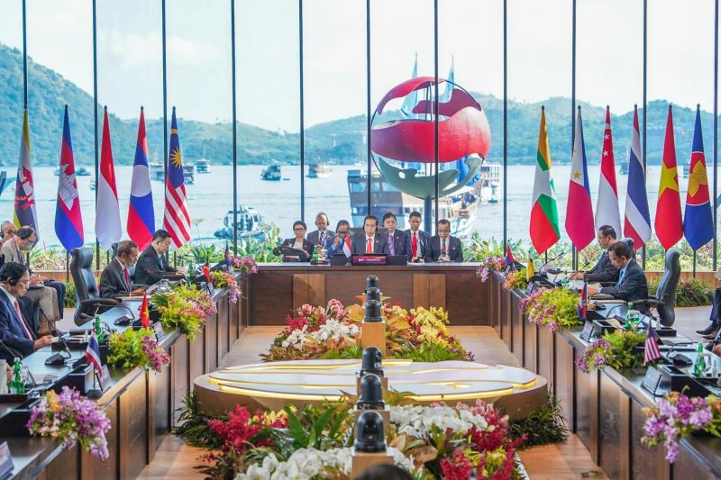
Indonesian President Joko Widodo opens the 42nd ASEAN Summit at Meruorah Hotel, Labuan Bajo, West Manggarai, East Nusa Tenggara. (ASEAN 2023 Gallery/Kominfo)

Most Association of Southeast Asian Nations (ASEAN) member countries have sizeable agricultural land and are the world's food source. However, Singapore ranked top in food security in Southeast Asia according to the 2022 GFSI Food Security Index. The assessment used four measurement indicators: affordability of food prices, supply availability, nutritional quality and safety, and sustainability and adaptation.
Global Food Security Index showed that Indonesia's food security was still below Singapore's in 2021. Indonesia's Food Security Index score was 59.2, while Singapore's was 77.4, the highest in Southeast Asia. In 2022, Indonesia's Food Security Index improved to 60.2, an increase of 1.7 percent compared to 2021. However, Indonesia's food security in 2022 was still lower than the global's at 62.2 and below the Asia-Pacific's at 63.4. Indonesia ranked 63rd out of 113 countries.
Indonesia's food security was quite strong compared to neighboring countries. Indonesia's food security ranked 4th in the ASEAN. ASEAN countries with the best food security are Singapore, Malaysia, and Vietnam.
GFSI assessed climate change policy and environmental and disaster management of a country's impact on food supply security. This is experienced by almost all ASEAN countries which strive to build an effective food system to survive amid rising food demand, limited land, and a warming climate.
Food Security
Despite its fertile soil, Indonesia still imports food commodities, namely sugar cane, corn, rice, beans, soybeans, wheat, and beef. Indonesian food imports were caused by several factors, e.g., agricultural land conversion and population growth rate. Sizeable agricultural land converted into settlements also reduced the number of food products in the country. On the other hand, the demand of the agricultural sector to produce food commodities is high due to the increasing population of Indonesia.
The Indonesian government has taken measures to anticipate food vulnerability and insecurity by formulating Food Security and Vulnerability Atlas (FSVA) under the Agriculture Ministry's Food Security Agency (BKP).
This is a complete list of the Food Security Index of Southeast Asian countries according to the GFSI in 2022:
- Singapore: 73.1
- Malaysia: 69.9
- Vietnam: 67.9
- Indonesia: 60.2
- Thailand: 60.1
- Philippines: 59.3
- Myanmar: 57.6
- Cambodia: 55.7
- Laos: 53.1
Sources:
- databoks.katadata.co.id
- impact.economist.com
- dataindonesia.id

